**EXPERIMENT 1**

**Aim :**

* Write a Program to Add 8-bit Numbers.
* Write a Program to Subtract 8-bit Numbers.

**Requirements :**

8085 Simulator IDE Software.

**Procedure :**

1. Go to the tools and select assembler.
2. Write the code in assembler window.
3. Go to the tools and select assemble & load in assembler window or press F8.
4. Check for errors and fix them.
5. Go to 8085 Simulator IDE and open simulation and start or press F1.
6. Open memory editor from tools option to observe output.

**Program to Add 8-bit Numbers :**

|  |  |  |  |
| --- | --- | --- | --- |
| **Address** | **Mnemonics** | **Operands** | **Comments** |
| 0000H | MVI A | 60H | Move 60H in Accumulator |
| 0002H | MVI B | 40H | Move 40H in register B |
| 0004H | ADD B |  | Add B to A & store the result in the Accumulator |
| 0005H | STA | 0020H | Store the content of Accumulator to 0020H memory location |
| 0008H | HLT |  | End of program |

**Screenshots :**

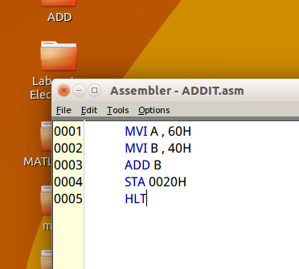 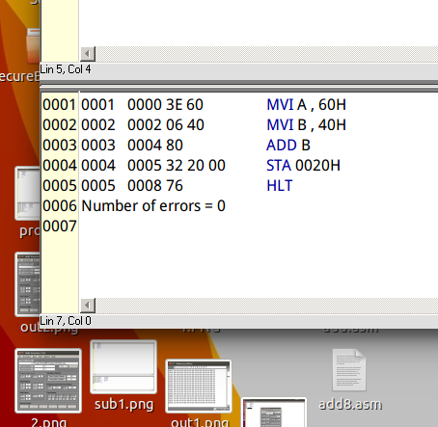

**Output :**

|  |  |
| --- | --- |
| **Before Execution** | **After Execution** |
| **A = 60H**  **B = 40H** | **A = A0H (at 0020H)** |

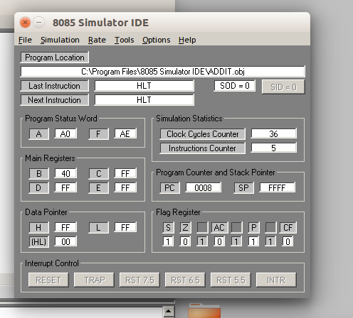 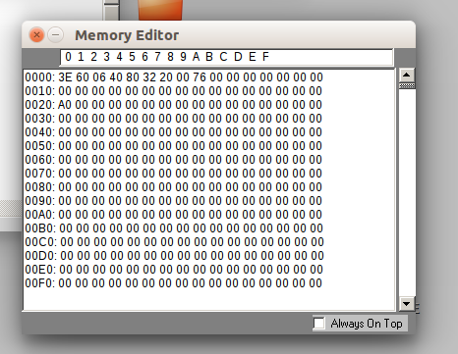

**Flow Chart :**

**Result :**

Program to Add 8-bit Numbers was implemented successfully.

**Program to Subtract 8-bit Numbers :**

|  |  |  |  |
| --- | --- | --- | --- |
| **Address** | **Mnemonics** | **Operands** | **Comments** |
| 0000H | MVI A | 60H | Move 60H in Accumulator |
| 0002H | MVI B | 40H | Move 40H in register B |
| 0004H | SUB B |  | Subtract B from A & store the result in the Accumulator |
| 0005H | STA | 0020H | Store the content of Accumulator to 0020H memory location |
| 0008H | HLT |  | End of program |

**Screenshots :**

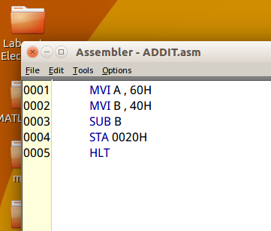 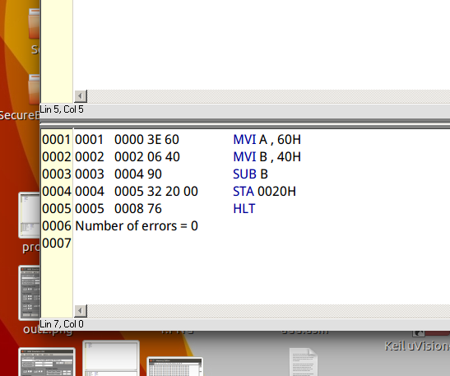

**Output :**

|  |  |
| --- | --- |
| **Before Execution** | **After Execution** |
| **A = 60H**  **B = 40H** | **A = 20H (at 0020H)** |

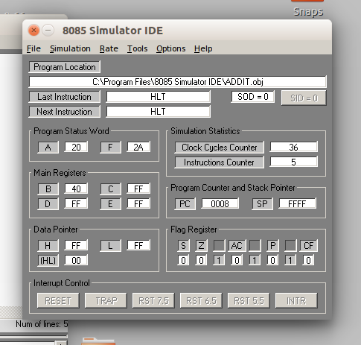 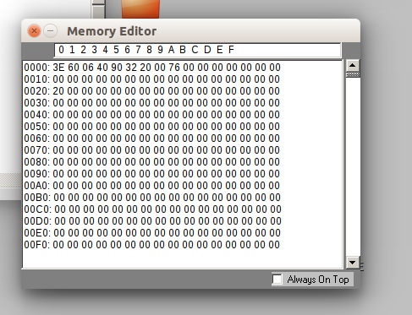

**Flow Chart :**

**Result :**

Program to Subtract 8-bit Numbers was implemented successfully.